1. Objective of whole project.

Compare MADGE data to other machine learning algorithms like SVM and neural networks. Accuracy and speed will be the two most optimized features, with accuracy without overfitting as the most interesting piece to explore.

1. What was implemented last week.

- Used the updated sigma calculation on the test data set for 2 dimensional spiral data.

Graphing the 2-D data requires a lot of calculations, since it requires a higher resolution for a stretched out spiral data set. I am testing a higher resolution since the range is larger. This is sort of an example of that spiral data’s classification as of now.

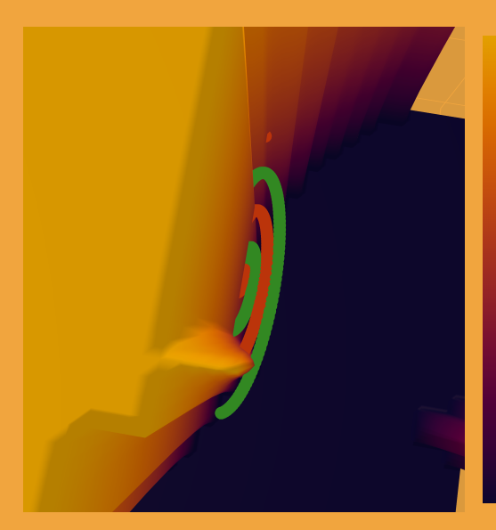

- Used the updated sigma calculation on the test data for n-dimensional MADGE data.

Accuracy is ~50% for this sigma calculation method. NaNs are being introduced, which is an indicator that the sigma being used is not large enough.

1. Plans for upcoming week.

Since code was updated for pointwise calculation, there had to be some tweaks to 2D classification methods. I will update the RUML as necessary. Continue to explore sigma calculation methods.

1. Objective of whole project.

Compare MADGE data to other machine learning algorithms like SVM and neural networks. Accuracy and speed will be the two most optimized features, with accuracy without overfitting as the most interesting piece to explore.

1. What was implemented last week.

- RUML has been updated with the new classes.

<https://docs.google.com/spreadsheets/d/1sktvtEGARj7zPEijXJN4fzFw9FgmM1plFmwsXs3W-pg/edit#gid=1133996158>

An adjustment was made to allow for multi-dimensional sets to be analyzed. The process is done via one main.py function, which I’m not sure how to put on the RUML. We can discuss.

- Implemented a method to import MNIST data and validate the data set. Accuracy for the first 100 points was maximized at 95%. The sigma of the data points was an important factor to the accuracy.

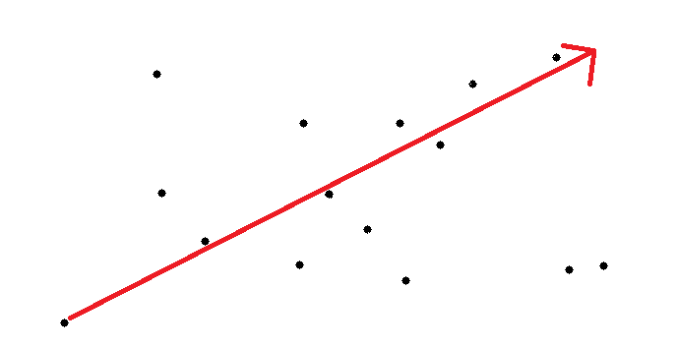

The sigma was determined by taking the magnitude of the vector that spans the range of the points and dividing it by a scalar. The logic is that each point will have an impact on the set with some divided by n value.

1. Plans for upcoming week.

Find an optimal sigma that can be replicated over all ranges.

Start working with other potential data sets.